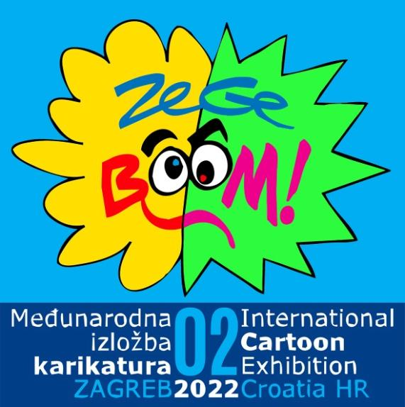
ZeGeBOOM! 2nd International Cartoon Exhibition_Zagreb_Croatia_2022

ENTRY FORM
Name
Surname
Pseudonym / Nickname
Street / No
Postal code
City
Country
Gender
e-mail
Phone / Mobile

CARTOONS | TITLE
Cartoon 1
Cartoon 2
Cartoon 3

Format: A4 (210×297 mm), RGB, JPEG, 300 dpi, High resolution
Title the cartoons: Name Surname Country_1, Name Surname Country_2, Name Surname Country_3
And send to: zegeboomail@gmail.com
No later than: November 25, 2022

Statement: By submitting this application, I confirm that you are familiar with the nature and content of the program for which you are applying and give consent to the organiser to use the collected data for this program, as well as information activities and media campaigns.

DATE | SIGNATURE

