2019 "Philosopher Lao Zi& Zen Master Huineng Caricatures"
in the "Eyes of Artists International Competition & Exhibition"
http://2143473974.bj.wezhan.cn/contestrules
The objects of the competition are cartoons, drawings, graphics and other works of fine art created by artists.
◆ Theme:
A. Philosopher Lao Zi
B. Zen Master Huineng Caricatures
Both themes are open to submission without limitation of quantities.
Works awarded in other competitions Can be included in this competition.
◆ Format
a) Maximum A3 (297mm x 420mm), minimum A4 (210mm × 297mm).
b) Printed submissions will not be accepted (work can be submitted in either digital or hand-drawn format; however, the electronic version of all submissions is definitely required).
c) Participants can also send digital files (scanned copy) with a minimum size of "300 dpi" in ".TIFF" or ".JPG" to cmiassn@vip.163.com .
◆ Contest
1.Works for the competition will be judged by the International Jury.
2. The Jury will award the following prizes and electronic Diplomas for each winner.
3. The Jury shall have the right to final distribution of the statutory prizes, change of their amount, or non-awarding them. Jury's decisions are final.
4.The competition results will be announced after the final selection in May 2019 at www.cmiassn.org. Taxes are subject to taxation according to Chinese tax regulation.
◆ Awards and Prizes
Grand Prize (1) 1500 USD
Gold Medal (2) 1000 USD (1 for Theme A and 1 for Theme B)
Silver Medal (4) 800 USD (2 for Theme A and 2 for Theme B)
Bronze Medal (6) $ 600 (3 for Theme A and 3 for Theme B)
Special Prize (30) 300 USD (15 for Theme A and 15 for Theme B)
◆ Participant Privileges
1. Artists will be given an electronic catalog.
2. Artwork sent to exhibitions will be exhibited in the country and abroad after the main exhibition.
◆ Competition Provisions
1. Organizers reserve the right to use all submitted artwork for advertising purposes without any special fees paid to the artists, which are being exhibited and reproduced in a variety of advertising materials as well as printed and circulated in catalogs.
2. The prize-winning works will become the property of the organizers and will be included in the collection of the Gallery.
3. The organizers of the exhibition shall be the final judges in the interpretation of the rules and regulations.
4. By sending his / her work, the artist agrees to the above mentioned rules and regulations.
5. By sending his / her work, the artist agrees to the publication of the author's profile in the post-exhibition album.
6. The finalist artworks are required to send the original artworks to the mailing address so that the organizer can keep them in the museum permanently.
7. No submissions will be returned.
◆ Notice
1.Participation in the competition is free of charge.
2.Organizers reserve the right to include the submitted works in Gallery and publishing.
3.The submitted artworks will be promoted on the internet and media.
4.Works should be accompanied by their photo or caricature, a short biographical note and a completed appli-form.

◆ Timetable and Contact Information
Submissions (original scripts are preferred) for receipt of artwork:
From January 28, 2019 to April 18, 2019
Deadline: Date of the postmark April 10, 2019
Deadline: Electronic submissions midnight April 18, 2019
◆ Contact Information
E-mail address: cmiassn@vip.163.com
Mailing address: 902 Suite, 3 Flat, No.3 Building,
Tianle Yuan, Beiyuan Road, Chaoyang District,
Beijing 100107
Tel: 0086-10-84937681
(Organizers are not responsible for damage during transport.)
For reference
------------------
For referenceIntroduction of LaoZi
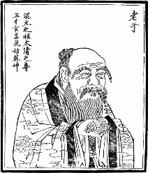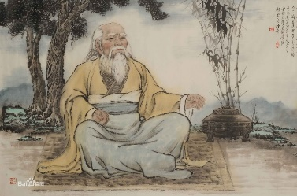
In traditional accounts, Laozi's personal name is given as Li Er (李耳Laozi is traditionally regarded as the author of the Tao TeChing (Daodejing), though the identity of its author(s) or compiler(s) has been debated throughout history.It is one of the most significant treatises in Chinese cosmogony. As with most other ancient Chinese philosophers, Laozi often explains his ideas by way of paradox, analogy, appropriation of ancient sayings, repetition, symmetry, rhyme, and rhythm. In fact, the whole book can be read as an analogy – the ruler is the awareness, or self, in meditation and the myriad creatures or empire is the experience of the body, senses and desires.
The Tao TeChing, often called simply Laozi after its reputed author, describes the Dao (or Tao) as the source and ideal of all existence: it is unseen, but not transcendent, immensely powerful yet supremely humble, being the root of all things. People have desires and free will (and thus are able to alter their own nature). Many acts "unnaturally", upsetting the natural balance of the Tao. The Tao TeChing intends to lead students to a "return" to their natural state, in harmony with Tao.[45] Language and conventional wisdom are critically assessed. Taoism views them as inherently biased and artificial, widely using paradoxes to sharpen the point.

Introduction of Huineng (Hui-neng) (638—713)
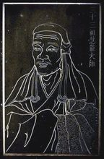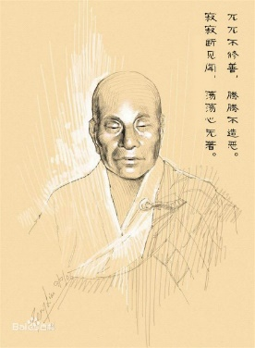
Huineng (Hui-neng) is a seminal figure in Buddhist history. He is the famous “Sixth Patriarch” of the Chan or meditation tradition, which is better known in Japanese as "Zen”. The focus of an immense body of lore that grew over the centuries, Huineng’s life mirrors the fortunes of Chan itself – a provincial Chinese version of Buddhism that rose to become a major religious and cultural force throughout East Asia. Tradition holds that Huineng was an uncouth “barbarian” youth who, because of his innate intuitive insight, surpassed his more cultured fellow monks to earn the official “dharma seal” certifying the authoritative transmission of Buddhist enlightenment, and thereby earning a lasting place in history. He is intimately associated with the Platform Sutra of the Sixth Patriarch, one of the most influential texts in all of Chinese Buddhism. Alleged to be a sermon from the lips of Huineng himself, this text provides a gripping first-person account of the Master’s life.
Its cryptic yet insightful discussion of Chan practice lays out the central concerns of Chan cultivation. Huineng’s discussion of the themes of inherent enlightenment, sudden awakening, and the non-dual nature of wisdom (Sanskrit: prajna) and meditation (Sanskrit: dhyana) resounds through later generations of Chan teachers, and continues to pose difficult philosophical challenges to this day.

Organising Committee

2019 Philosopher Lao Zi& Zen Master Huineng Caricatures in the Eyes of Artists International Competition
Deadline：April18th, 2019
Title
Author | Name |  | Gender | □male □female
 | Nationality |  | Resident Country
Contact | Address
 | Post Code
 | Tel No. |  | tax
 | e-mail |  | website
Biography of Author
Signature

