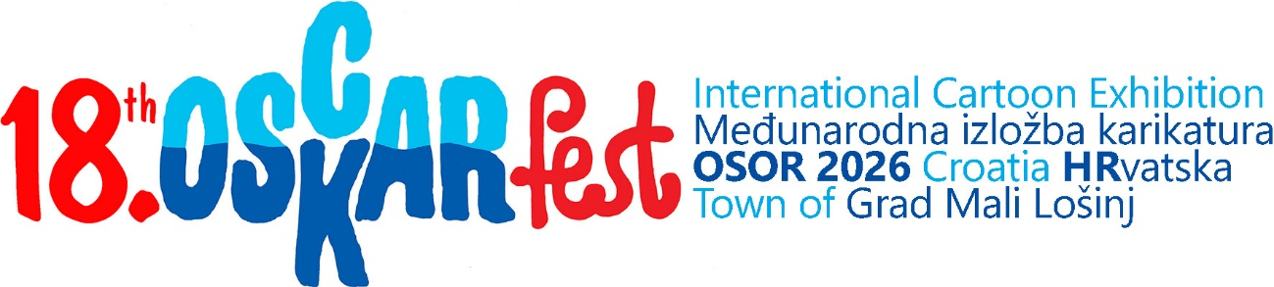

Topic: CELEBRATION on a DESERT ISLAND
Deadline: May 15, 2026
Email: oscarfest.croatia@gmail.com
ENTRY FORM
Name_
Surname_
Artistic name_
Street, No._
Postcode_
City_
Country_
Email_
Place and date of birth_
Sex Male_ Female_
Date_
Signature_

The author agrees to the application of cartoons on OSCARfest souvenirs in a limited edition (for publicity, awards to voters, sponsors, donors and self-financing of the festival). The author will receive author's copies.
YES_ NO_

Attachments should be named as follows:
Name-Surname-ARTISTIC NAME-Country-1 (2, 3, Entry Form)
(For example: Dragutin-Kovačević-DADO-Croatia-1)

Please insert a portrait of yourself (photo or caricature)
>

PLEASE FORWARD THE APPLICATION FORM to your fellow cartoonists!

